**ST. XAVIER’S COLLEGE**

**(Affiliated to Tribhuvan University)**

Maitighar, Kathmandu



**Computer Graphics Lab Assignment #7**

**Submitted by:**

Sushant Gautam

013BSCCSIT043

**Submitted to:**

|  |  |
| --- | --- |
| Er. Anil Sah  Lecturer, St. Xavier’s College |  |

**Date of submission:** September 8, 2015

**SOURCE CODE**

**//---------------------------------------------------------------------------**

**#include <vcl\vcl.h>**

**#pragma hdrstop**

**#include "Unit1.h"**

**//---------------------------------------------------------------------------**

**#pragma resource "*.dfm"**

**TForm1 *Form1;**

**int x,y;**

**//---------------------------------------------------------------------------**

**__fastcall TForm1::TForm1(TComponent* Owner)**

**: TForm(Owner)**

**{**

**}**

**//---------------------------------------------------------------------------**

**void __fastcall TForm1::Button1Click(TObject *Sender)**

**{**

**x=Image1->Width;**

**y=Image1->Height;**

**for(int i=x; i>=0; i--)**

**{**

**for(int j=y; j>=0; j--)**

**{**

**int a=x-i;**

**int b=j;**

**Image2->Canvas->Pixels[a][b]=Image1->Canvas->Pixels[i][j];**

**}**

**}**

**}**

**//---------------------------------------------------------------------------**

**void __fastcall TForm1::Button2Click(TObject *Sender)**

**{**

**x=Image1->Width;**

**y=Image1->Height;**

**for(int i=x; i>=0; i--)**

**{**

**for(int j=y; j>=0; j--)**

**{**

**int a=i;**

**int b=y-j;**

**Image3->Canvas->Pixels[a][b]=Image1->Canvas->Pixels[i][j];**

**}**

**}**

**}**

**//---------------------------------------------------------------------------**

**OUTPUT**

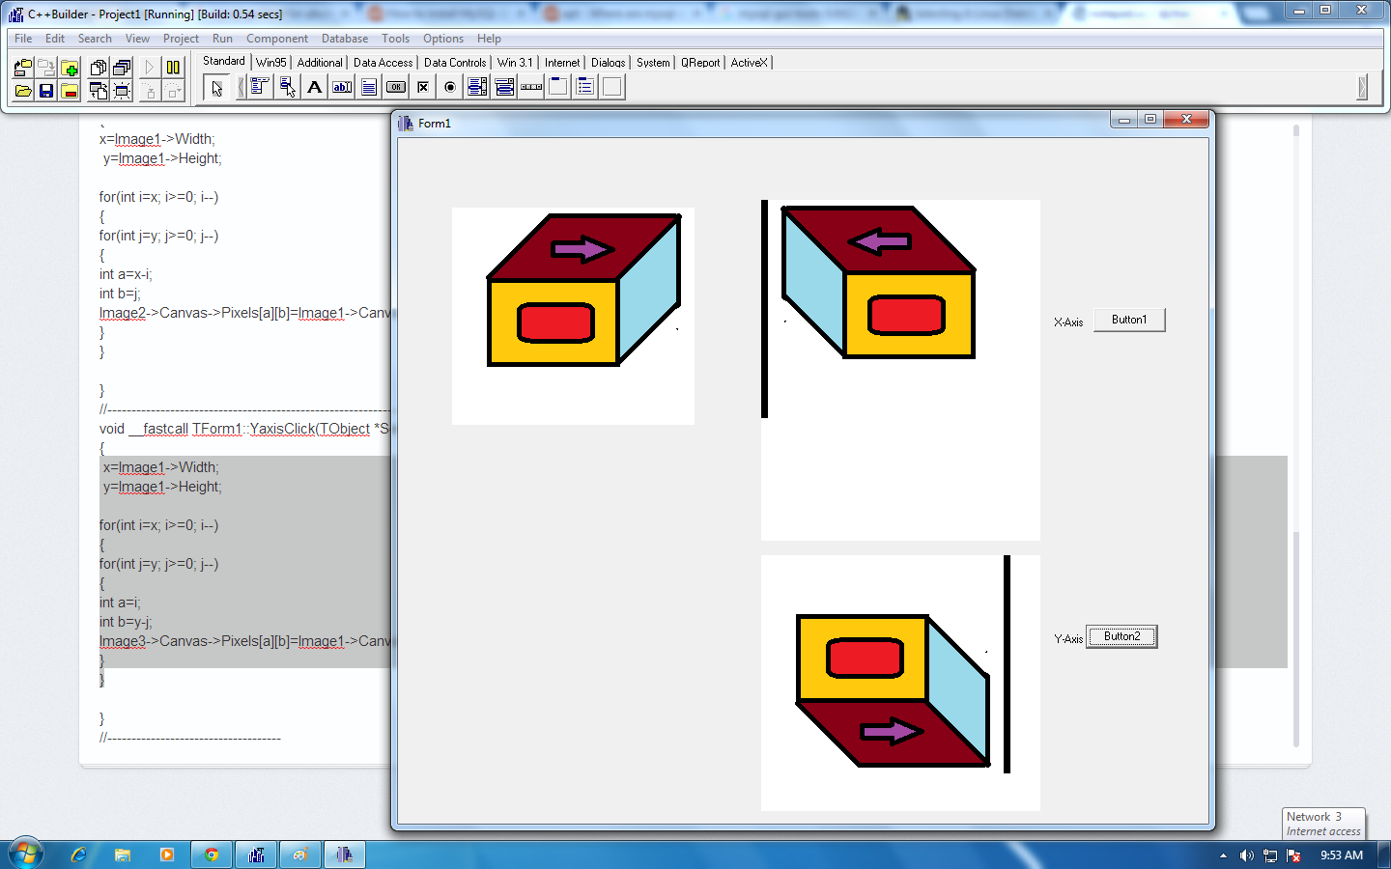

Fig. Reflection about X-Axis and Y-Axis